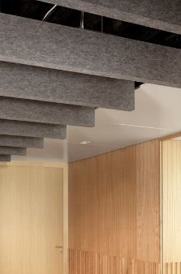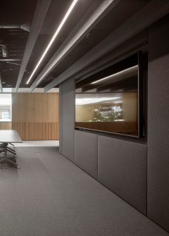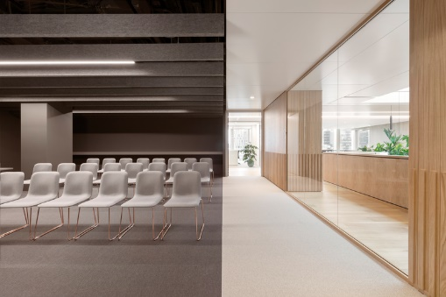

**Hunter Douglas** HeartFelt**®** Baffle **felt ceiling**

1. **Product description (various configs, modulations)**HeartFelt® Baffle ceiling is a box shaped panel made from 6.5mm felt from non-woven thermo-formable virgin[1] PES fibres. Dimensions (wxh) from 40x100 mm up to 80x500 mm with an open space between the baffles.

|  |  |  |
| --- | --- | --- |
| Dimensions | Space width | Openness % |
| 40x200mm | 200 mm | 83% |
| 50x250mm | 250 mm | 83% |
| 80x400mm | 400 mm | 83% |
| variable | 50-500 mm | variable |

The carriers into which the baffles are clipped are made from coated black (1863) steel with a height of ca 24mm.

HeartFelt® Baffles are available in 5 shades of grey. The shades in colour are achieved by varying the ratio between the white and black in the mix of the base material.

|  |  |
| --- | --- |
| HD Colour codes | |
| Shades of Grey | |
| White | 7593 |
| Light grey | 7596 |
| Middle grey | 7597 |
| Dark grey | 7598 |
| Black | 7594 |

|  |
| --- |
| **HeartFelt® colours** |
|  |

**Technical drawing**

|  |
| --- |
|  |
|  |
|  |

**Panels**

* + Dimension 40x200 mm (40HB200), 50x250 mm (50HB250) and 80x400 mm (80HB400) or variable dimensions (xxHBxxx) with the upper flanges pointing inward and inserted into an aluminium holding profile. The baffles are supported by steel spring clips inserted in the holding profile and clipped into the carrier. After alignment the baffles are locked with plastic locking clips that are inserted under the spring clips.
  + Minimum panel length 200 mm. Maximum panel length 2000 mm.
  + Panel ends:
    - Open
    - Closed with a separate end cap
    - Closed with folded panel ends
    - Any combination of the above options

1. **Carriers/ stabilisation profile**
   * 0.6mm steel
   * Available in black 1863
   * Modules from 50mm to 500mm in 50mm increments
   * Carrier length ca 5,-m

|  |  |  |
| --- | --- | --- |
| Article code | Description | Length |
| 332580 | Fe combi carrier no module | 4995 mm |
| 332581 | Fe combi carrier no module no splice | 4995 mm |
| 332582 | Fe combi carrier variable M | 4995 mm |
| 332583 | Fe combi carrier M50 | 4995 mm |

1. **Accessories**
   * Baffle splices made from 6.5 mm felt material. Supplied flat and to be folded and inserted into the open baffle ends on site. The aluminium holding profile is spliced with the profile splice inserted and fixed into the slot.  
     *Note: Panel splicing is independent from carrier position!*
   * Carrier splices, black 1863.
   * End caps from 6.5mm felt material in the same colours as the panels. Supplied flat and to be folded and inserted into the open baffle ends on site
   * Hangers:
     + Standard rod hanger with suspension adjustment spring
     + Gripple® wire hangers for individually suspended baffles
2. **Spans**
   * Panel span (ctc distance of the carriers): max 1900 mm
   * Panel cantilever (distance from panel end to 1st carrier): max 500 mm
   * Carrier span (ctc distance of the hangers): 1200 mm
   * Carrier cantilever (distance from carrier end to 1st hanger): max 300 mm
   * Distance between stabilisation profiles: 2400 mm
3. **Properties**
   * Unique revolutionary product. Up till now, not existing in the ceiling market
   * Based on proprietary and patented technology
   * Has a “soft” look and creates a warm and comfortable ambiance
   * Acoustic performance comparable to similar perforated metal baffle ceilings with non-woven acoustic tissue and open spaces
   * No special tools required. If necessary, panels can be cut-to-size on site with just a circular saw
   * Light weight system:

|  |  |  |
| --- | --- | --- |
| Module | Module | Weight |
| 40HB200 | M250 | 3.43 kg/m2 |
| 50HB250 | M300 | 4.24 kg/m2 |
| 80HB400 | M500 | 4.08 kg/m2 |

* + High impact resistance of the panels. Not easily damaged. However, the ceiling is not suited for use in sport hall applications where ball impact resistance is required

1. **Fire properties**Reaction to fire classification according EN 13501-1: Class B-s1,d0 (all dimensions, all modules, all shades of grey).
2. **Acoustical properties**

**30HB200**

|  |  |  |
| --- | --- | --- |
| Module | αw | NRC |
| 150 mm | 0.45(H) | 0.51 |
| 200 mm | 0.45(H) | 0.50 |
| 300 mm | 0.45(H) | 0.51 |
| 400 mm | 0.45(H) | 0.44 |

**50HB250**

|  |  |  |
| --- | --- | --- |
| Module | αw | SAA |
| 250 mm | 0.50(H) | 0.60 |
| 500 mm | 0.45(H) | 0.49 |

**80HB400**

|  |  |  |
| --- | --- | --- |
| Module | αw | NRC |
| 300 mm | 0.60(H) | 0.66 |
| 400 mm | 0.55 (H) | 0.60 |

1. **Application/ intended use**  
   HeartFelt® Baffle ceilings are designed as suspended ceilings for interior applications and can be used in exposure classes A and B according Table 8 of EN 13964:2014.  
   HeartFelt® panels subjected to a climate chamber test (HD Materials lab) show no humidity retention op to RH 90%. At higher humidity levels (RH >90%) water droplets are adhering to the tips of the individual fibres and an increase in weight is noted. This would imply that HeartFelt® ceilings could be used in swimming pool environments (Swimming pool climate: max. T40°C /RH70% / 0.5% NaCL3). For

**Other characteristics**  
Emissions to indoor air:

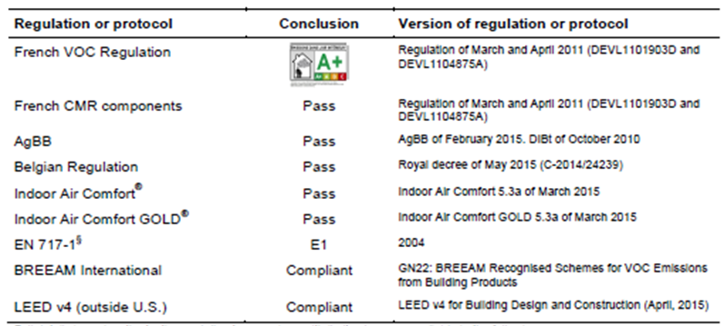



REACH Regulation (EU/1907/2006):

* + does not contain any substances mentioned in the candidate list of SVHC substances or which are mentioned in Annex XIV or Annex XVII of the regulation.
  + HeartFelt® Baffles isare not subjected to the requirement to supply REACH information to downstream users.

C2C certification:

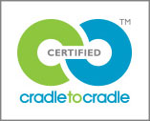

* + HeartFelt® Baffle ceilings are made from a single material (virgin PES fibres) without any finishes.   
    The carriers are made from coated material (steel) and can easily be re-used or for 100% recycled. The hangers are made from galvanised steel and can either be re-used or for 100% recycled. Cradle to Cradle Certified™ Bronze for the complete system has been awarded[2].  
      
    <http://www.c2ccertified.org/products/scorecard/ceiling-systems-hunter-douglas-europe-b.v>

Oekotex® Confidence in Textiles - Standard 100 – Tested for harmful substances certification:

* + 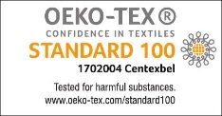The Trevira CS fibres are already Oekotex Standard 100 certified (product class I, babies and small children up to the age of 3 year). Certificate 12.0.03665, validity date 31 March 2020.
  + Oekotex Standard 100 certification for product class IV (furnishing materials for decorative purposes) for the HeartFelt® Baffles. Certificate 170.0.2004, valid till 28 February 2021.

Greenguard by UL Laboratories

* The GREENGUARD Certification Program (formerly known as GREENGUARD Indoor Air Quality Certification) gives assurance that products designed for use in indoor spaces meet strict chemical emissions limits, which contribute to the creation of healthier interiors.
  + UL 2818 - 2013 Standard for Chemical Emissions for Building Materials, Finishes and Furnishings, certificate valid till 16 February 2020.
  + UL 2818 - 2013 Gold Standard for Chemical Emissions for Building Materials, Finishes and Furnishings, certificate valid till 16 February 2020.

|  |  |
| --- | --- |
| https://spot.ulprospector.com/Content/images/categories/greenguard-gold.png | https://spot.ulprospector.com/Content/images/categories/greenguard.png |

Staining/ Clean ability/ Dirt retention[3]:

* + The tested colour (7599 Anthracite) has a high resistance to staining by chlorinated water (colour comparison after 1-hour exposure to 50mg active chlorine per litre water)
  + Clean ability tests with standardised pollutions and different cleaning agents shows that HeartFelt® Baffle ceilings have (wet) cleaning characteristics that are at least at par or better than aluminium ceilings (plain strip 0280). Moderate to strong fuzzing/ pilling may occur depending on the number of rubbings applied. Scratching of the aluminium material occurs when exposed to the same treatment.
  + Dirt retention with standard pollutions on HeartFelt material, compared with plain aluminium, is ca 5-8 higher (weight-to-weight) after shake-off.

Bacterial growth/ fungal growth:

* Depending on bacterial strain the material may/ may not show a propensity to bacterial growth. We advise to consult with the client concerning the bacterial strain(s) that is (are) relevant for the project and need to be tested.
* The felt material does not show any visual or microscopic fungal sporulation or growth.

Maintenance:

* Heartfelt® Baffles ceilings can be dry-cleaned with a feather duster or by vacuuming the panels.
* If necessary panels can be wet cleaned with plain water or cleaning agents (see above).

Light reflection according EN 410:

|  |  |  |
| --- | --- | --- |
| Colour | Reflectance_SOLAR (%) | Reflectance_VIS (%) |
| 7593 (white) | 59.7 | 60.7 |
| 7596 (light grey | 32.2 | 31.8 |
| 7597 (medium grey) | 20.3 | 20.6 |
| 7598 (dark grey) | 8.9 | 8.5 |
| 7594 (black) | 3.6 | 3.5 |

Colour fastness to artificial light according ISO 105-B02:2014:

|  |  |
| --- | --- |
| Colour | Colour fastness |
| 7593 (white) | 6-7 |
| 7596 (light grey | 6-7 |
| 7597 (medium grey) | 6-7 |
| 7598 (dark grey) | 7 |
| 7594 (black) | 7 |

1. Virgin material means made from new fibres. Due to the fire retardant properties of the fibres it is not possible to use recycled material. Also the mandatory chemical analysis of the material for C2C certification makes it virtually impossible to work with fibres from recycled material.
2. *Cradle to Cradle Certified*™ is a certification mark licensed by the Cradle to Cradle Products Innovation Institute.
3. All test results are based on comparison of the change in colour/ surface of original (nontreated/ exposed) samples to tested samples.